Utility to Update Delivery Zones from an Excel Spreadsheet

The utiltiy can be run FROM Customer ____________ TO Customer ___________

The Default Zone transfers to Ship to Delivery Zone when the Zip Code in the SHIPTO cannot find a matching Zip Code in the Excel File.

For Example

From Customer: TACO BELL To Customer: TACO BELL

From Ship To: To Ship To: zzzzzzzzzzzz

I typed DEFAULT Carrier = USA

From the Attached Excel File, the CORRECT RESULTS

Shipto TacoBell should become Carrier TRUCK Zone USA

Shipto TacoJoes should become Carrier TRUCK Zone USA

Shipto TacoPA1 has matching Zip Code 19020 form Carrier TRUCK this should change to Zone NE1

Shipto TacoPA2 has matching Zip Code 19067 form Carrier TRUCK this should change to Zone NE3

Shipto TacoPA3 has matching Zip Code 19047 form Carrier TRUCK this should change to Zone NE2

Shipto TacoPA4 has matching Zip Code 19067 form Carrier TRUCK this should change to Zone NE3

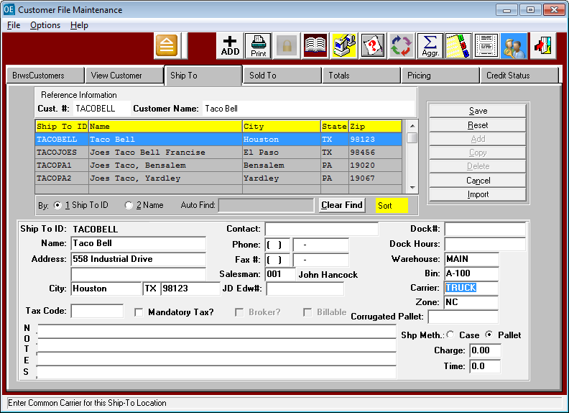

Sincerely,

**Joseph Hentz, President***ASIlogo* 301 Oxford Valley Rd, Ste 1713

 Yardley PA 19067

 work    215-369-7800  
 mobile 215-479-5561   
Email: [**Joe@advantzware.com**](mailto:Joe@advantzware.com)

Website: [**www.Advantzware.com**](http://www.Advantzware.com)